BATH RAILS INSTALLATION REQUISITION SUPPLEMENT

POSITION OF BATH RAILS
For all rails please specify the measurement from the rim of the bath/wall behind the taps to the middle of the rail.
Specify angle of rail.
Height from rim of bath to the middle of the rail (H).
Distance from wall behind taps to the middle of the rail (D).

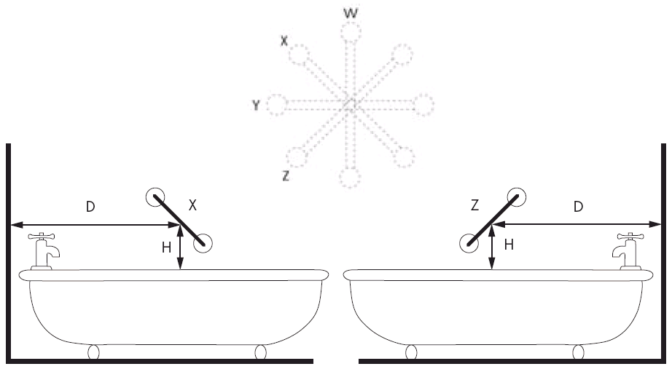
Rails and Minor Adaptations
Requisition Number:
Pin Number:
Client Name:
Client Address:

Information
1) Length of rail(s):

2) Position of rail(s):

3) Fixing of rail(s) into Wood:
Brick:
Concrete:
Other:

4) Other Information:

