DOORWAY INSTALLATION REQUISITION SUPPLEMENT
Height from step to middle of rail (H).
Specify length of rail.
Specify left (L) or right (R) side (when facing the outside of the door).
Clarify height of step (A)
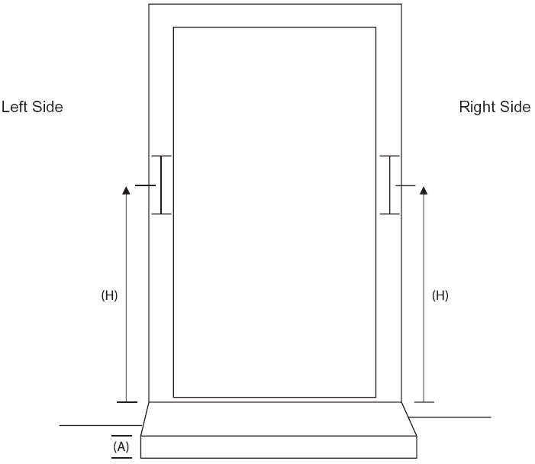
Rails and Minor Adaptations
Requisition Number:
Pin Number:
Client Name:
Client Address:

Information
1) Length of rail(s):

2) Position of rail(s) Left side ascending:
Right side ascending:

3) Length or rail(s) into Left side:
Right side:

4) Other Information:

