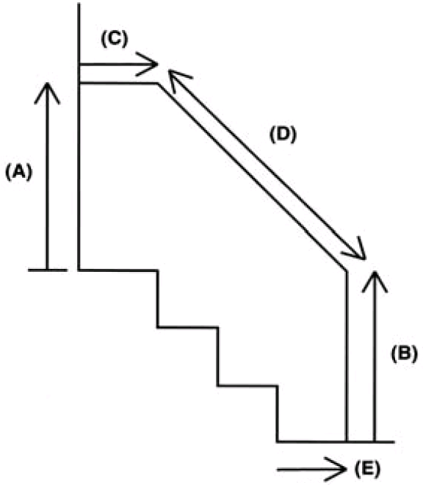
Rails and Minor Adaptations
Requisition Number:
Pin Number:
Client Name:
Client Address:

Information

Rails where there are several steps

8) Fixing at top Brick:
Wood:
Concrete:
Earth:

8) Fixing at bottom Brick:
Wood:
Concrete:
Earth:

9) Other Information

1) Length of rail (A):

2) Height of rail (B):

3) Length of rail (C):

4) Length of rail (D):

5) Distance from step (E):

6) Number of rails One side:
Both side:

7) Position of rails Left side ascending
Right side ascending

