Toilet Rails

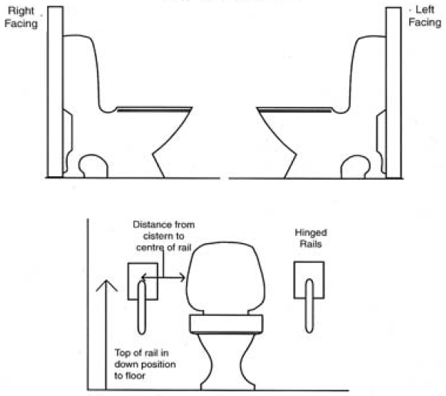
Rails and Minor Adaptations
Requisition Number:
Pin Number:
Client Name:
Client Address:

Information

1) Number of rail(s):

2) Length of rail(s):

3) Height of rail(s):

4) Fixing of rail(s) into Wood:
Brick:
Concrete:
Other:

5) Other Information:

