Ref / PIN NO: | Client Name:
 | Client Address:
Doorway
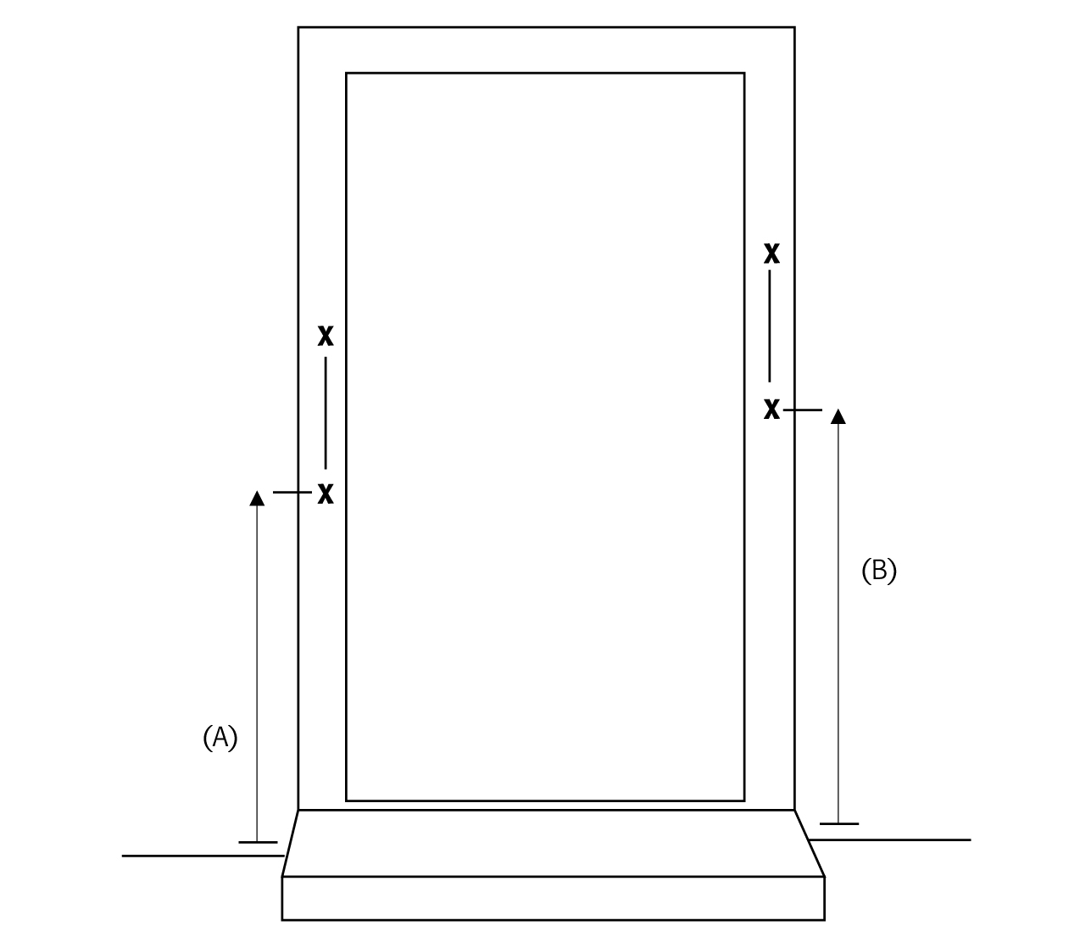

1. Number of rail(s): |  | 4. Height measured to bottom of rail from  floor - Left side (A)
2. Position of rail:
- Left side ascending or |  | - Right side (B)
- Right side ascending (tick) |  | 5. Fixing of rail(s) into: wood/brick/concrete/  other:
3. Length of rail - Left side:
- Right side: |  | 6. Other information:

