Ref / PIN NO: | Client Name:
 | Client Address:
Drop Down Rails
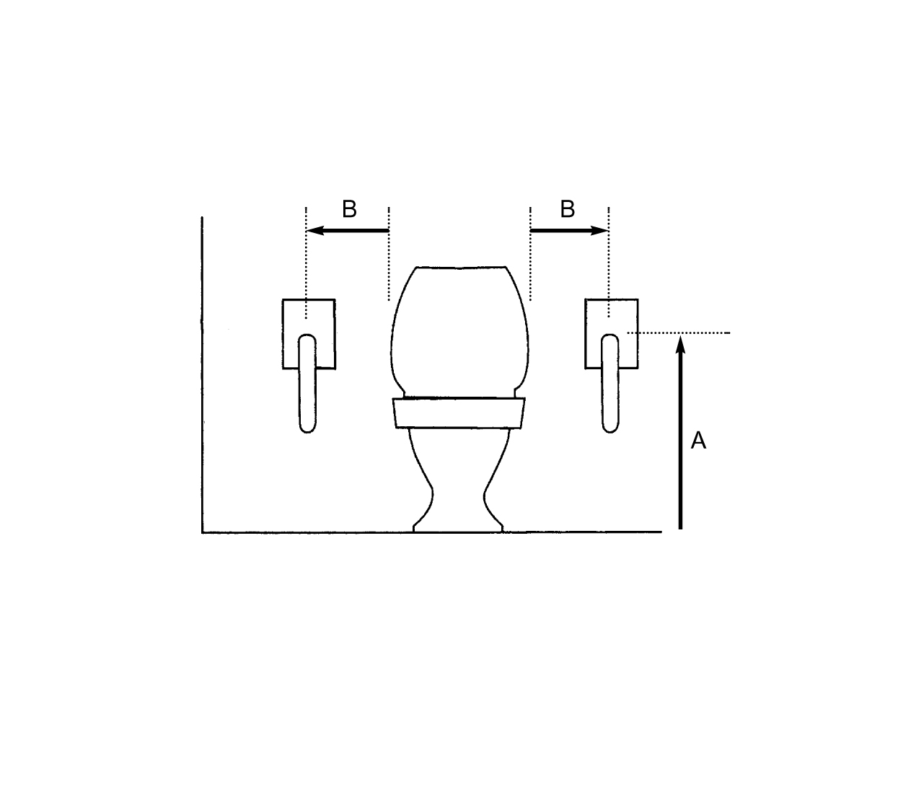

1. Height from floor to top of rail (A):
2. Distance from edge of cistern/toilet to centre of rail (B):
3. Fixing of rail(s) into: wood/brick/concrete/other:
4. Other comments:

