Ref / PIN NO: | Client Name:
 | Client Address:
Stair Rails Straight
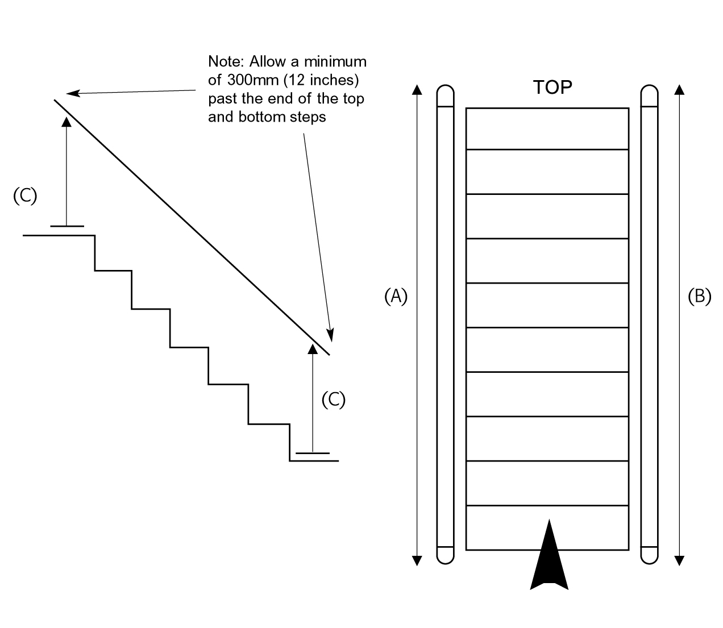
1. Number of rail(s): |  | 4. Fixing of rail(s) into: wood/brick/concrete/  other:
2. Length of rail(s) (including 300mm overhang):
A |  | 5. Other information:
B
3. Height of rails from front of tread nosing to
top of rail: (C)  Or height of existing banister |  | 6. Newel Post Rail: Yes No

