Ref / PIN NO: | Client Name:
 | Client Address:
Toilet Rails
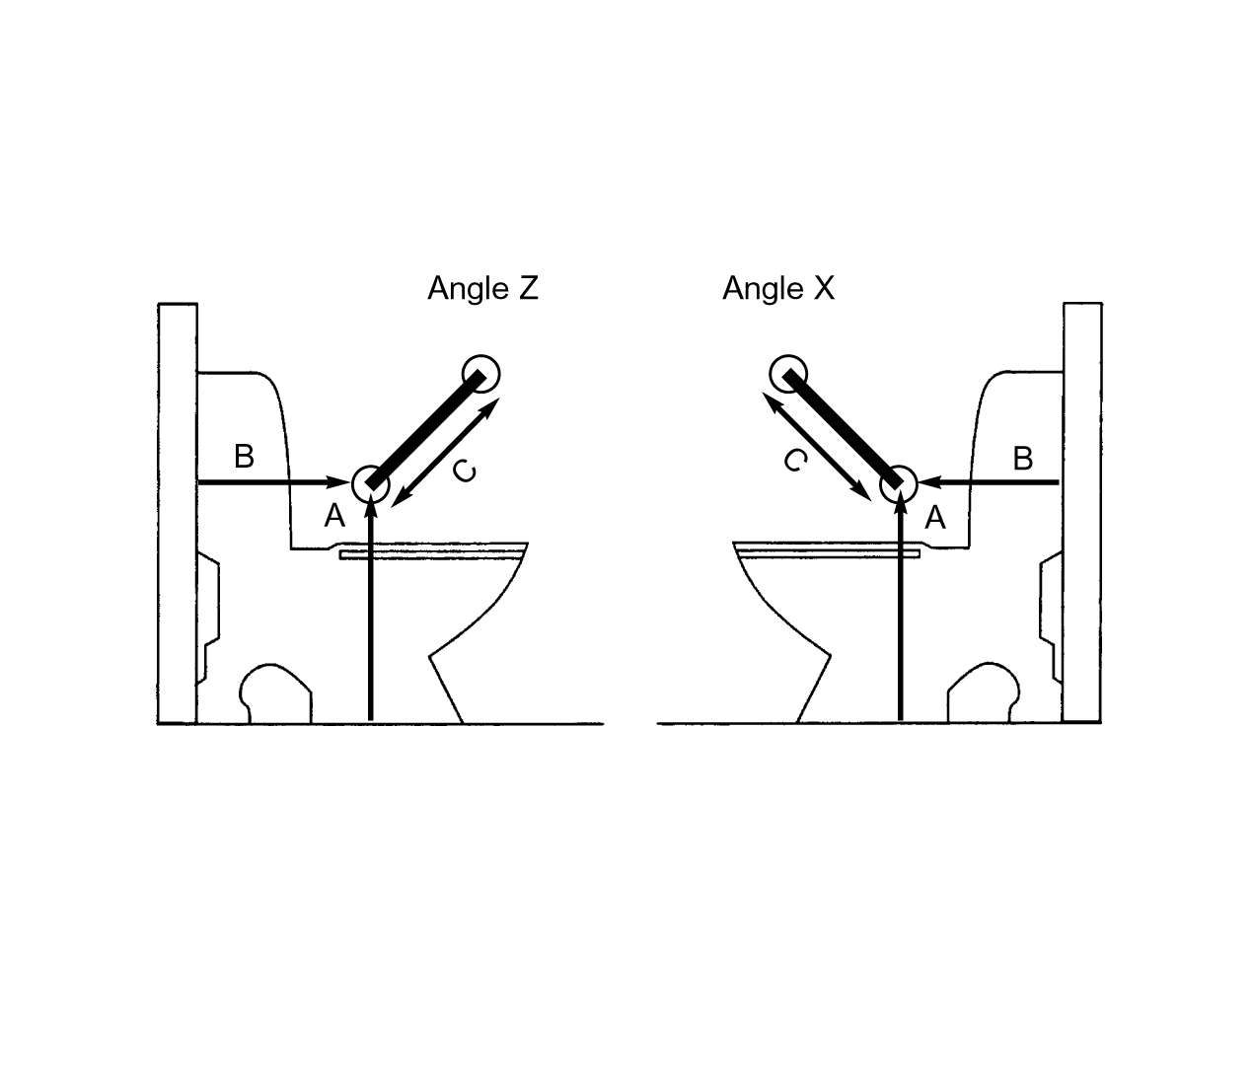
1. Angle of rail (tick as appropriate): |  | W X Y Z
2. Height from floor to bottom of rail (A):
3. Distance from wall to bottom of rail (B):
4. Length of rail (C)
5. Fixing of rail(s) into: wood/brick/concrete/other:
6. Other comments:

